**CPE223 – Signals and Systems**



**Lab # 10**

**To Show the Response of Continuous Time Signals Using Laplace Transform in MATLAB.**

|  |  |
| --- | --- |
| **Name** | Muhammad Aizaz Arshad |
| **Registration Number** | 088 |
| **Class** | FA18-BCE-A |
| **Instructor’s Name** | Umair Shafique Khan |

**OBJECTIVE:**

* Explain the output of Laplace Transform using MATLAB.

**REQUIRED EQUIPMENT:**

**Software:**

* **MATLAB**

**METHODOLOGY:**

To convert continuous time signals in to frequency domain, we use Laplace. A benefit of Laplace on Fourier is, every signal has a Laplace Transform if its Fourier either exists or not. Fourier Transform’s existence can be checked by using ROC. To find the Laplace transform of any given signal first command syms is used to define the symbolic variables t and s.

Next, the function is defined as symbolic expression and the (unilateral) Laplace transform is computed. There are two commands in MATLAB for Laplace transform:

* laplace (function, s)
* ilaplace (function, s)

When signal is to be transform from time domain to frequency domain, we use laplace command and when signal is to be transformed from frequency domain to time domain ilaplace command is used.

**CONCLUSION:**

In this Lab, we studied about Laplace Transform, which is only applicable on Continuous Time Signals. Every signal has a Laplace Transform either its Fourier exists or not. From the graph of Laplace Transform from which we can find that Laplace transformation is more powerful tool than Fourier transformation.

**IN LAB TASKS:**

**Question 1:**

%in lab task1

syms t s

f= -1.25+3.5.*t.*exp(-2.*t)+1.25.*exp(-2.*t);

display('Laplace Transformed:')

f1=laplace(f,s)

LHS=f

f2=ilaplace(f1) ;

RHS=f2

display('Hence Proved')

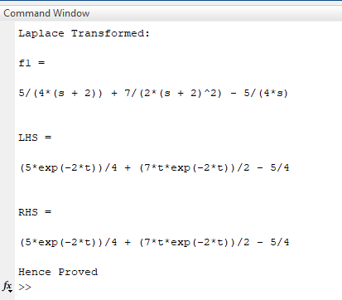

**Question 2:**

%Inlab task2

syms t s

Y= 1./s + 2./(s+4) + 1./(s+5);

pretty(Y)

display('Ilaplace of given signal:')

y= ilaplace(Y,t)

RHS=laplace(y,s);

pretty(RHS)

display('HENCE PROVED')

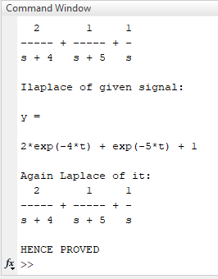

**Question 3:**

% Inlab task3

syms t s

X=(s.^2 + 5*s + 4)/(s.^4 +1);

pretty(X)

x= ilaplace( X,t)

% subplot(2,1,1)

% ezplot(x)

% title('LHS')

pretty(x)

B= [ 1, 5, 4,];

A= [ 1, 0, 0, 0, 1];

[R P K]= residue(B,A)

X1= R(1)/(s-P(1))+R(2)/(s-P(2))+R(3)/(s-P(3))+R(4)/(s-P(4));

x1= ilaplace(X1,t)

% subplot(2,1,2)

% ezplot(x1)

% title('RHS') % If you plot a graph they are exactly same.

pretty(x1)

